## Implementing **Catalog Search** using ElasticSearch and Kibana Dashboard:

Configuration Steps:

1. Download Elastic Search
2. Download Kibana Webapp
   1. Copy Kibana to Apache Directory
3. In config.js of Kibana, pointed the Kibana to local elastic search instance
4. Start Elastic Search
   1. Go To Bin folder of ES and .\elasticsearch
      1. C:\catalog\elasticsearch-1.1.1\bin>.\elasticsearch
   2. Insert data into elastic search using postman google plugin (REST API) (This will typically be an automated replication between a transaction DB and ElasticSearch Datastore)
      1. chrome-extension://fdmmgilgnpjigdojojpjoooidkmcomcm/index.html
      2. POST to <http://localhost:9200/catalog/appliance>
         1. 9200 is the ES port
         2. There is an index name followed by a document type
      3. Enter the JSON object
5. Start Tomcat
   1. C:\catalog\apache-tomcat-7.0.53\bin>.\startup.bat
6. Load Kibana webapp
   1. <http://localhost:8080/kibana-3.0.1>

Screenshots of the implementation:

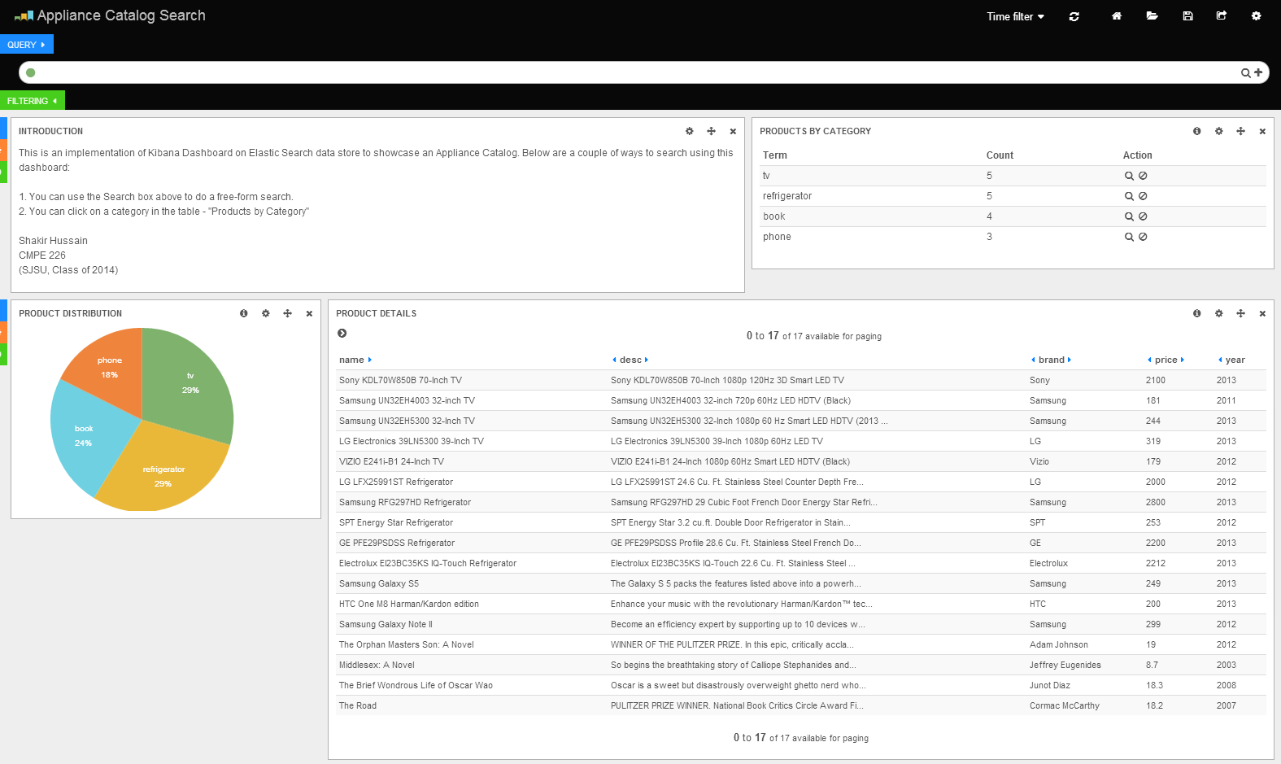

Click on a product Category (E.g.: TV)

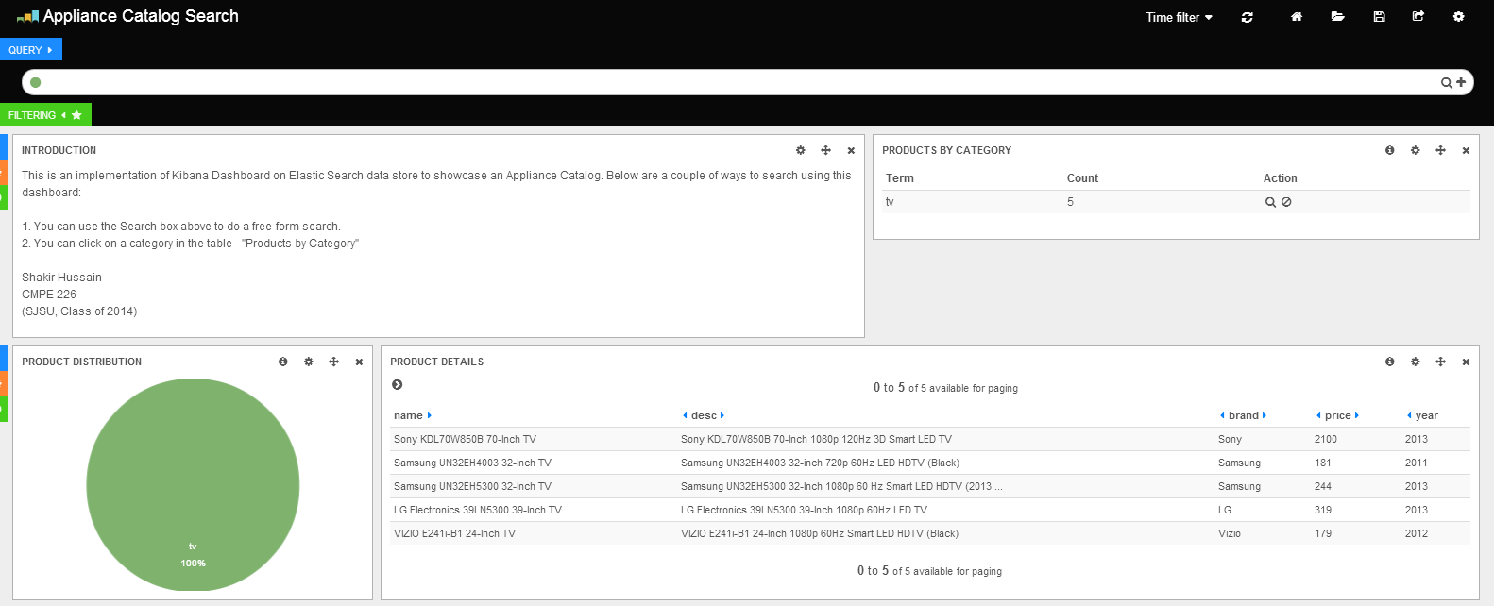

Search for a brand within TVs by entering “Samsung” in the “Query” textbox:

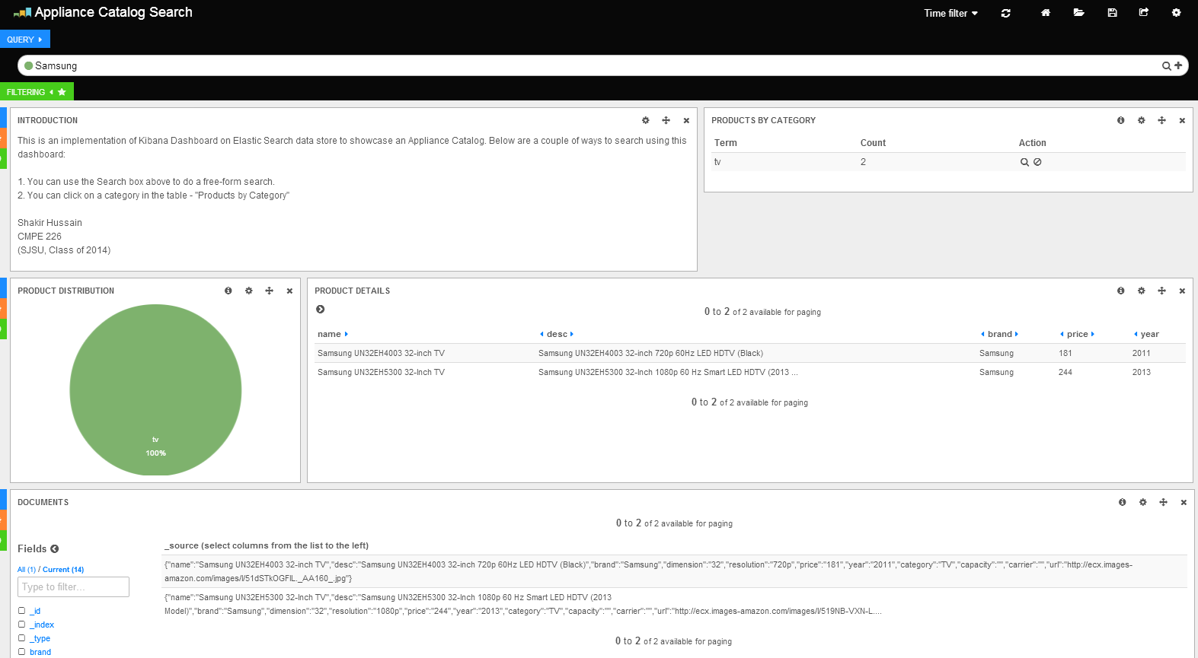

## Walkthrough - Product Catalog WebApp on Mongo DB:

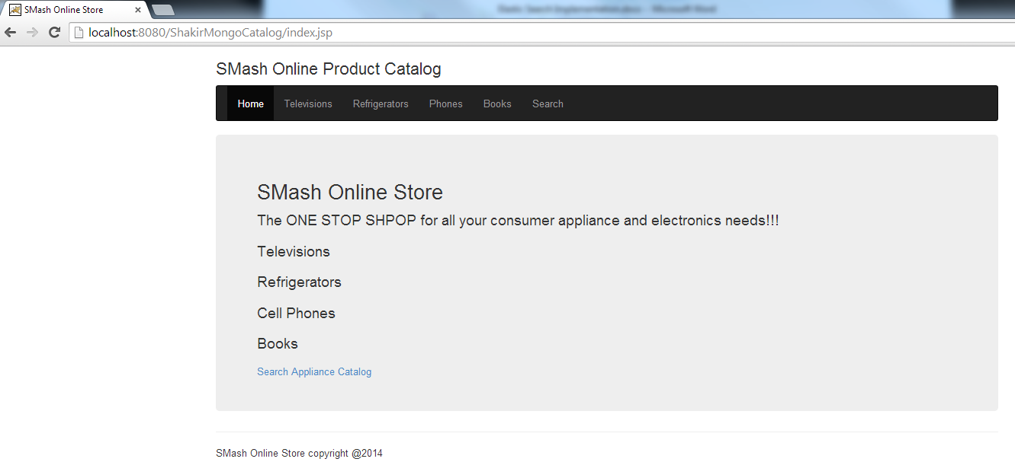

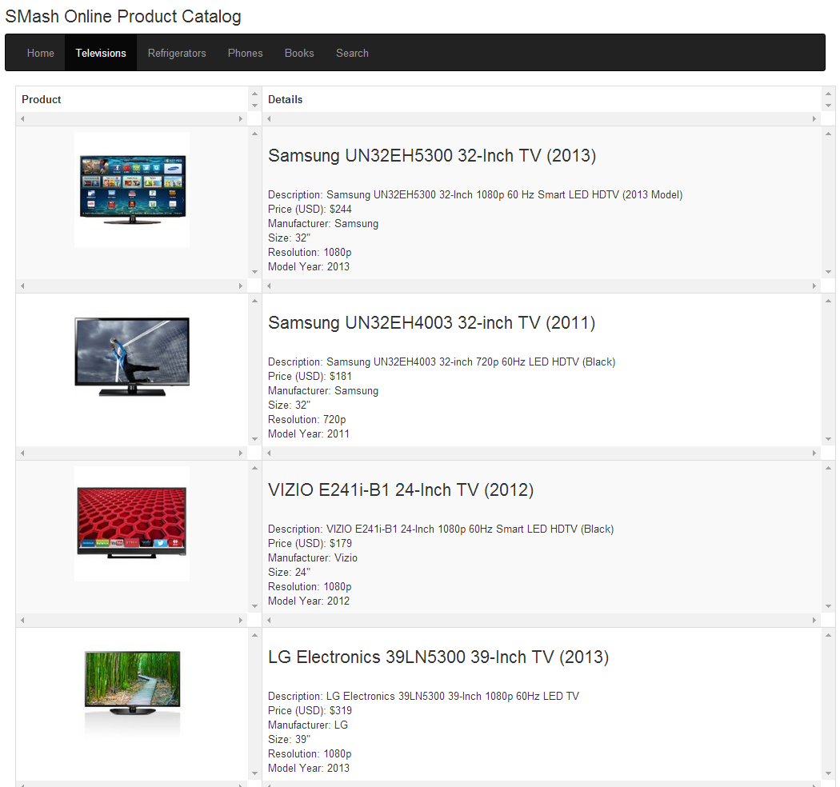

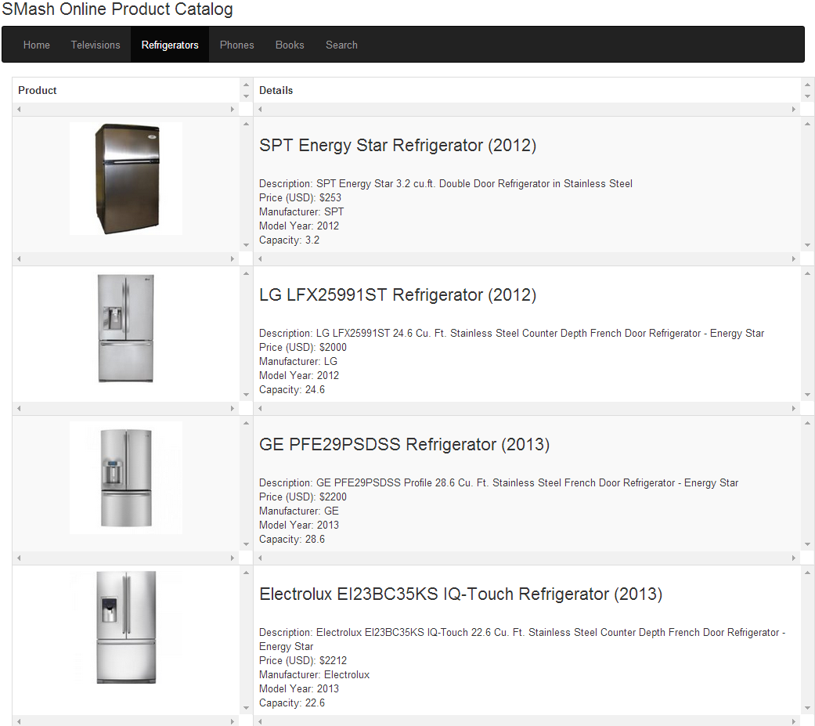

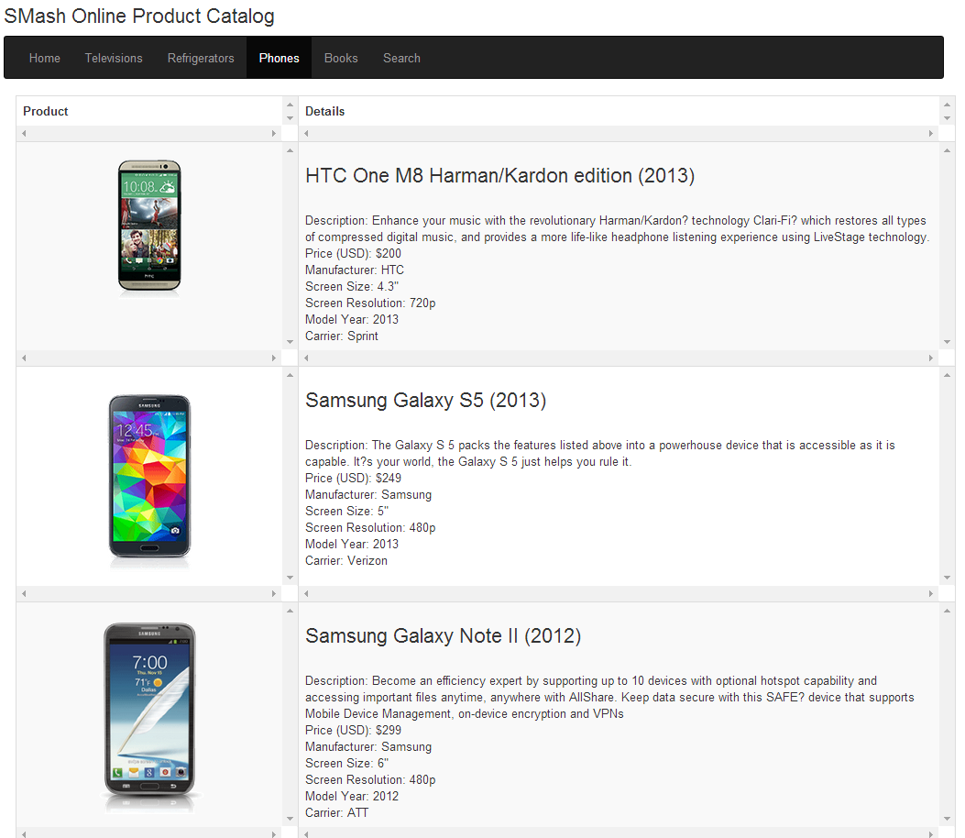

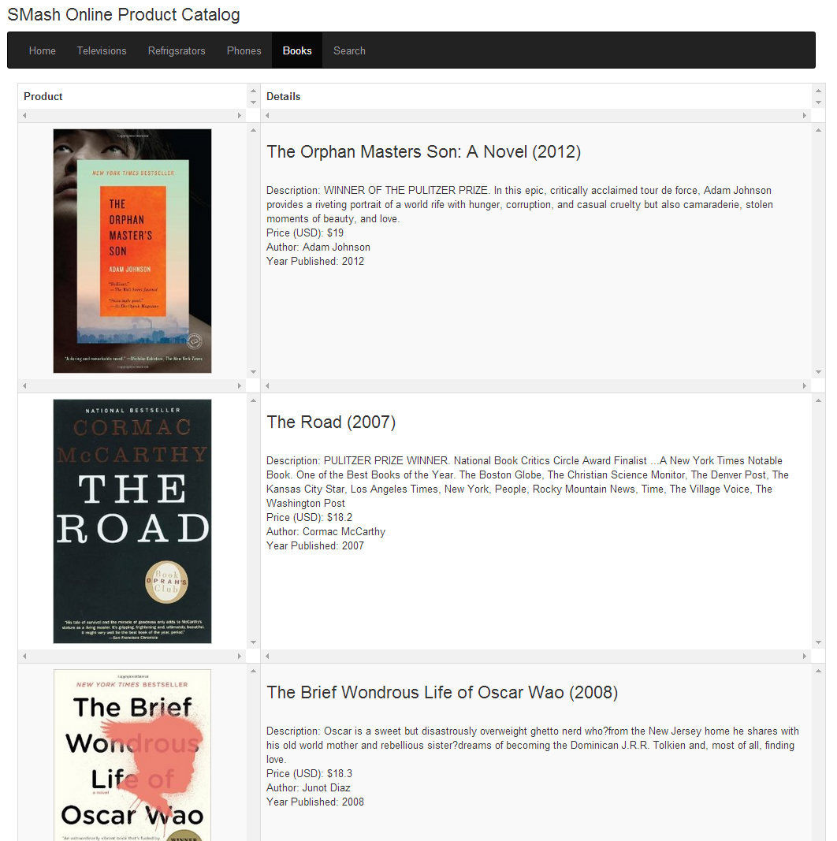

**Search implementation using Elastic Search**

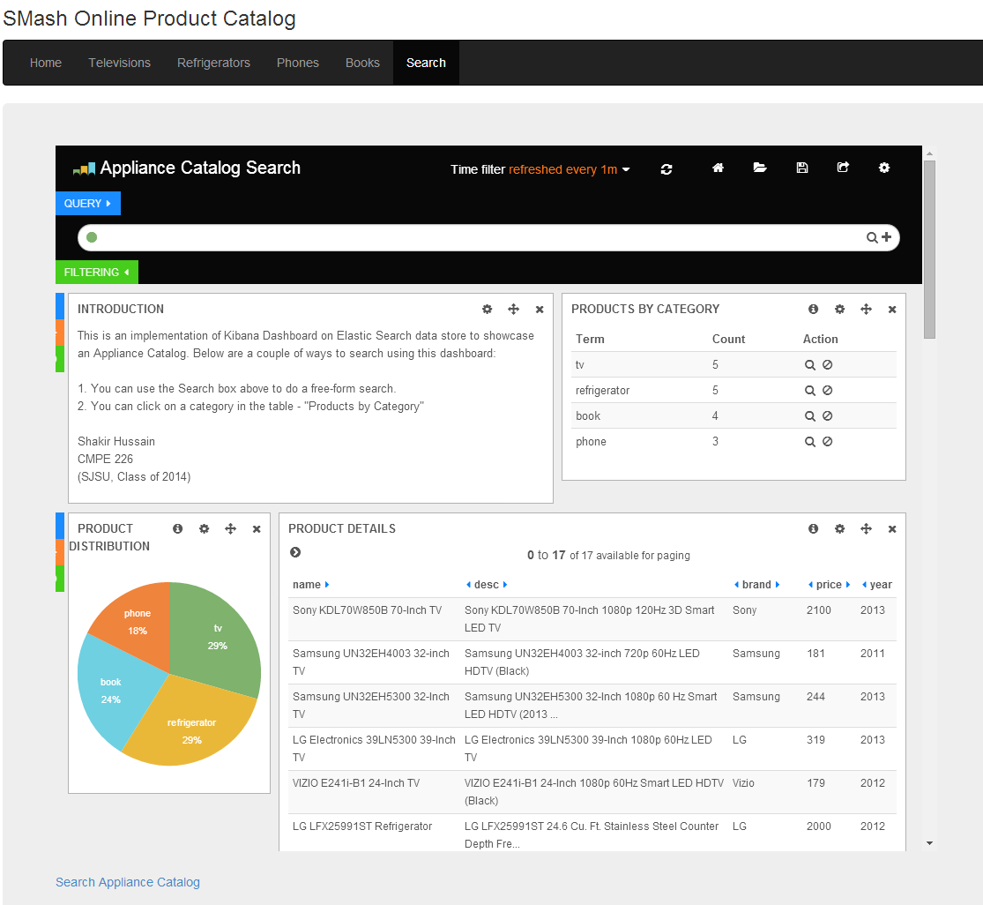

**Search for products with brand Samsung:**

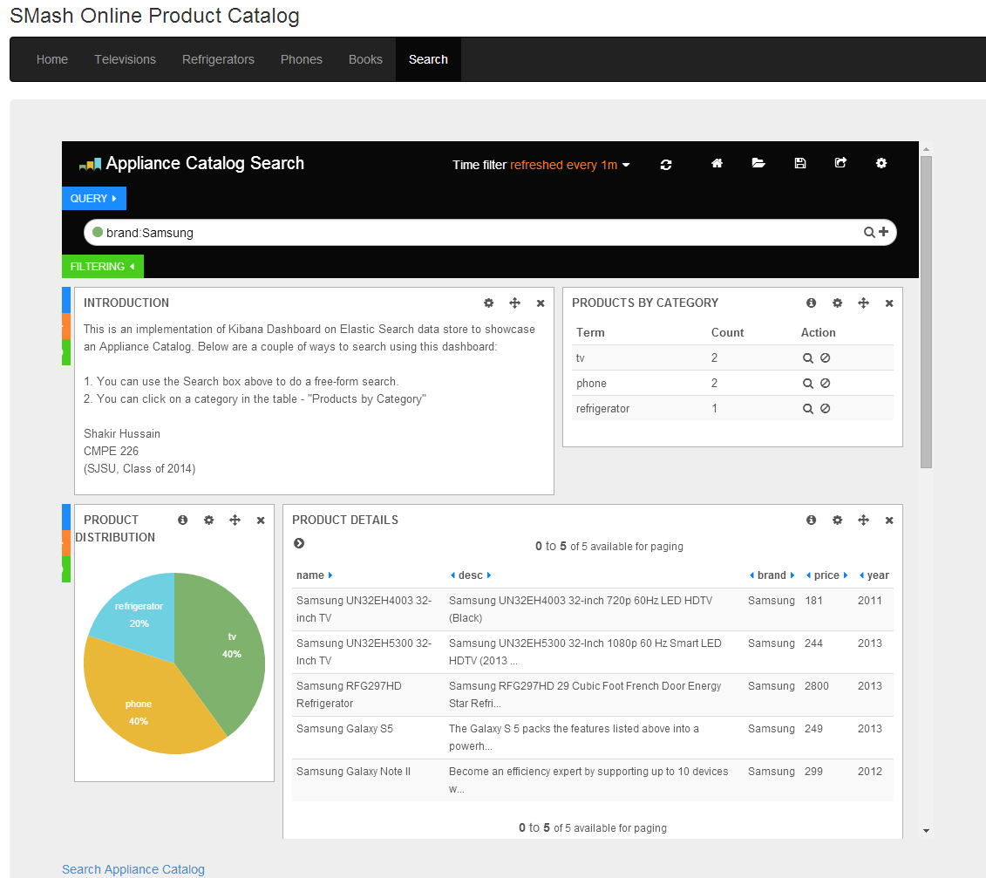

MongoDB Output:

